#### *Scientific topics of the Conference:*

– additive technologies based on welding, metallurgical and hybrid processes;

– electron beam technologies in the field of additive technologies;

– 3D printing;

– selective laser melting;

– plasma transferred arc surfacing;

– mathematical modelling of physical processes in additive technologies;

– materials for additive technologies;

– additive technologies in the production of plastic parts and medical products;

– materials science in additive technologies;

– non-destructive testing in additive technologies.

***Working languages of the Conference:***

#### Ukrainian and English.

For participation in the Conference, please, fill in the registration form and send it to the Organizing Committee.

The Conference is organized in form of plenary and poster papers session. Proceedings of abstracts will be published before the Conference start. Paper size is up to 2 A4 pages (size 12, 1.5 spacing, margin 2 cm from each side), including Figures, Tables and References.

Participation in the conference is possible alive and on-line.

The papers approved by the Program Committee will be published in E.O. Paton Electric Welding Institute Journals in issues of 2023 year.

The Conference Proceedings of abstracts will be posted in electronic form on the conference website.

To present the plenary paper, 20 minutes will be given (15 minutes for presentation and 5 minutes for discussion). Demonstration of papers will be provided using the multimedia projector.

***Deadlines***

|  |  |
| --- | --- |
| Applications for participation and sending theses of papers | before 07.11.2023 |
| Applications for participation without paper | before 21.11.2023 |
| Conference program | before 22.11.2023 |
| Payment of registration fee | before 27.11.2023 |

***Exhibition***

Exhibition on «Welding and related technologies» will take place together with the Conference at building No. 4 of the E.O. Paton Electric Welding Institute. The Exhibition is opened from 10.00 to 16.00 on 27.11.2023. Terms of participation in the exhibition are negotiated separately.

***PREVIOUS PROGRAM***

|  |  |
| --- | --- |
| **27 November** | **Monday** |
| 09:00 – 11:00 | Registration of Conference  participants |
| 10:00 – 11:00 | Plenary papers |
| 11:00 – 11:20 | Coffee break |
| 11:20 – 13:00 | Plenary papers |
| 13:00 – 13:40 | Coffee break |
| 13:40 – 17:00 | Plenary papers |
| 10:00 – 16:00 | Poster papers session |
| 17:00 – 20:00 | Friendly dinner-meeting |

***Registration fee***

The registration fee makes 150 Euro (alive) and 100 Euro (on-line).

The registration fee covers payment for preparation and publication of Conference Proceedings of abstracts, coffee breaks between the sessions, friendly dinner, participant’s box, participant’s certificate as well as other organizing activities. An invoice for payment of the registration fee is sent by participant’s request.

***Registration of the Conference participants***

Registration of the Conference participants will be held at the lobby of the E.O. Paton Electric Welding Institute (building No.4) on November 27 from 09.00 to 11.00 at E.O. Paton Electric Welding Institute, 11 Kazymyr Malevych str., Kyiv, Ukraine.

***Accommodation***

Conference participants book accommodation independently.

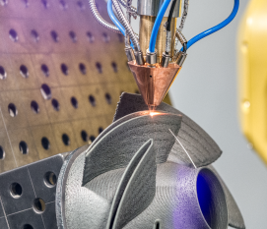

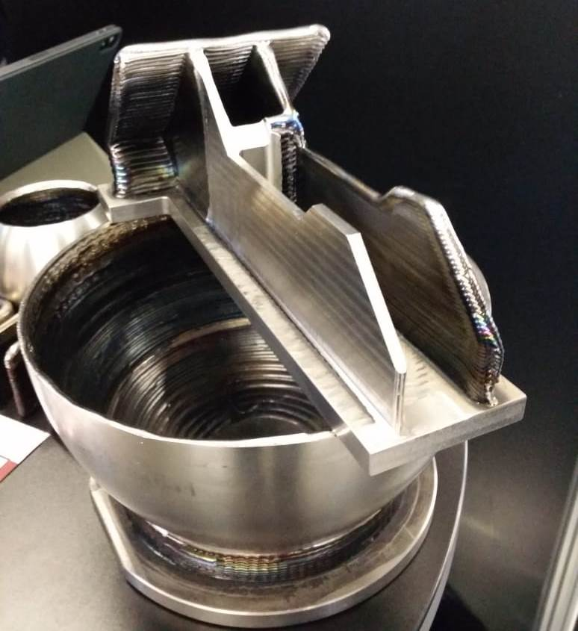

**REGISTRATION FORM**

***CURRENT DIRECTIONS OF THE***

***DEVELOPMENT OF ADDITIVE***

***TECHNOLOGIES***

*27 November 2023*

E.O. Paton Electric Welding Institute

*Kyiv, Ukraine*

Family name

Name

Country

Employment

Scientific degree

Title of paper

Correspondence address:

Tel.:

E-mail:

I would like to:

❑ present plenary paper *alive*

❑ present plenary paper *on-line*

❑ present poster paper

❑ participate in the Conference without paper

**PROGRAM COMMITTEE**

E.O. Paton Electric Welding Institute, Kyiv

*Prof. I. Krivtsun (chairman),*

*Prof. L. Lobanov,*

*Prof. S. Akhonin,*

*Prof. S. Maksimov,*

*Prof. V. Poznyakov,*

*Prof. V. Shapovalov,*

*Prof. V. Nesterenkov,*

*Prof. M. Iurzhenko;*

*Prof.V. Kvasnytskyi, NTUU «Igor Sykorsky Kyiv Polytechnic Institute»;*

*D. Kovalchuk, NVO «Chervona Hvylya»,*

*Kyiv;*

*Dr. O. Som, Plasma-Master Co., Ltd., Kyiv*

*Correspondence address*

E.O. Paton Electric Welding Institute,

11, Kazymyr Malevych str., Kyiv, 03150,

Ukraine.

*Organizing Committee*

Dr. Oleksandr Zelnichenko,

E.O. Paton Electric Welding Institute,

Tel.: (38044) 205-23-90,

E-mail: [journal@paton.kiev.ua](mailto:journal@paton.kiev.ua)

Dr. Iryna Romanova

Tel.: (38044) 205-22-26

E-mail: [romanova@paton.kiev.ua](mailto:romanova@paton.kiev.ua)

[www.pwi-scientists.com/eng/at2023](http://www.pwi-scientists.com/eng/at2023)

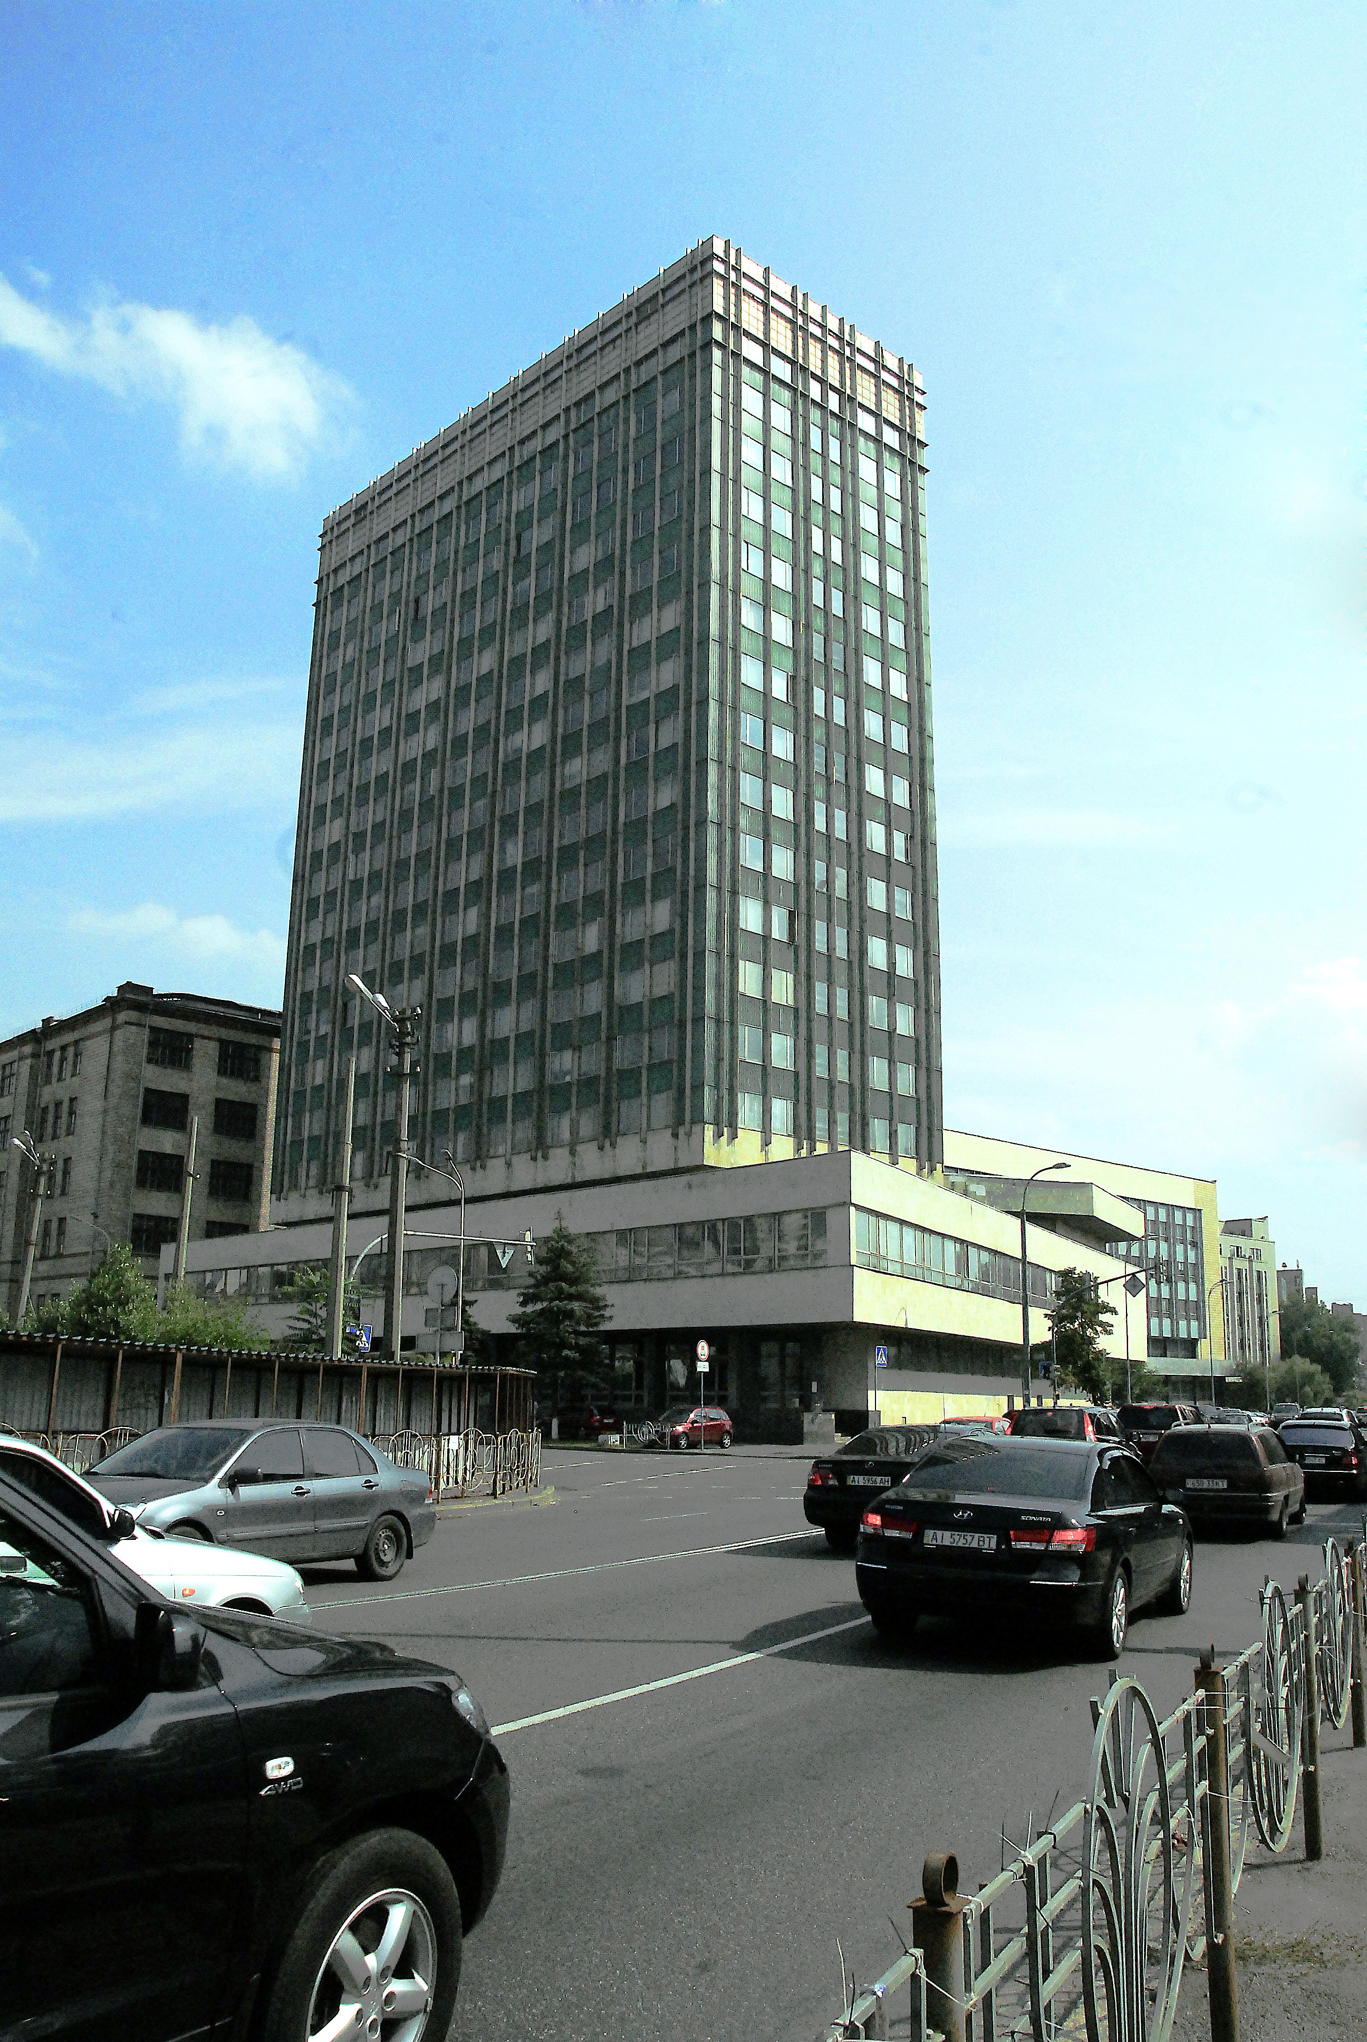

E.O. Paton Electric Welding Institute of the NASU

Ukrainian Welding Society

International Association «Welding»

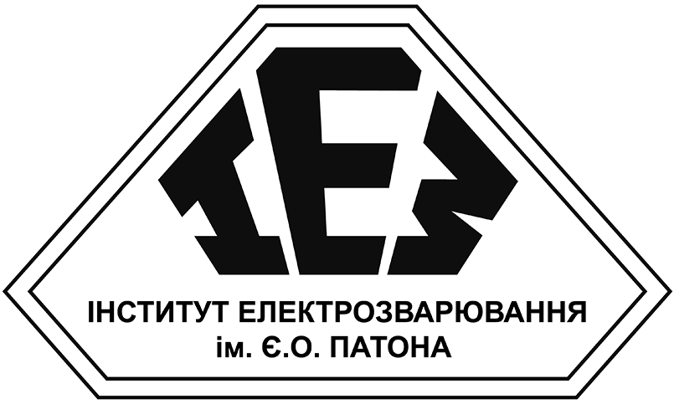  

**SCIENTIFIC AND TECHNICAL**

**CONFERENCE**

**CURRENT DIRECTIONS OF THE**

**DEVELOPMENT OF ADDITIVE**

**TECHNOLOGIES**

*The conference is devoted to the 105th anniversary*

*of the birth of academicianBoris Paton*

**INVITATION**

*E.O. Paton Electric Welding Institute*

*27 November 2023*

*Kyiv, Ukraine*

*Information support*

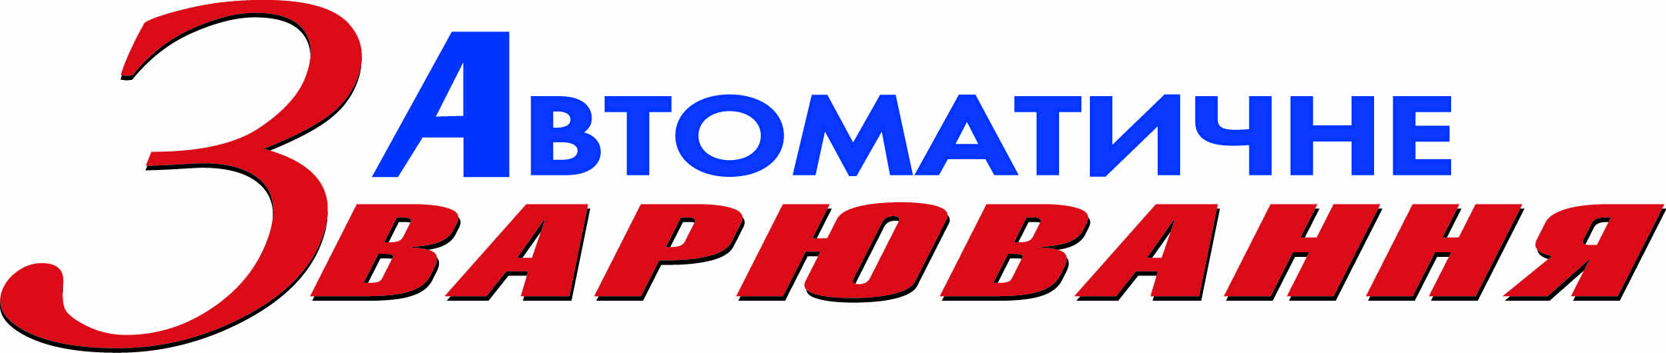*«Automatic Welding»*

*«Advanced Electrometallurgy»*

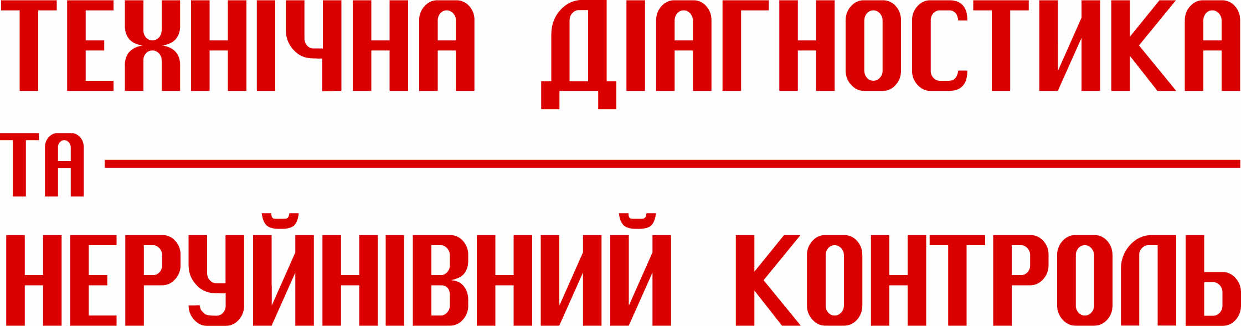*«Technical Diagnostics and Non-Destructive Testing»*

*With support*

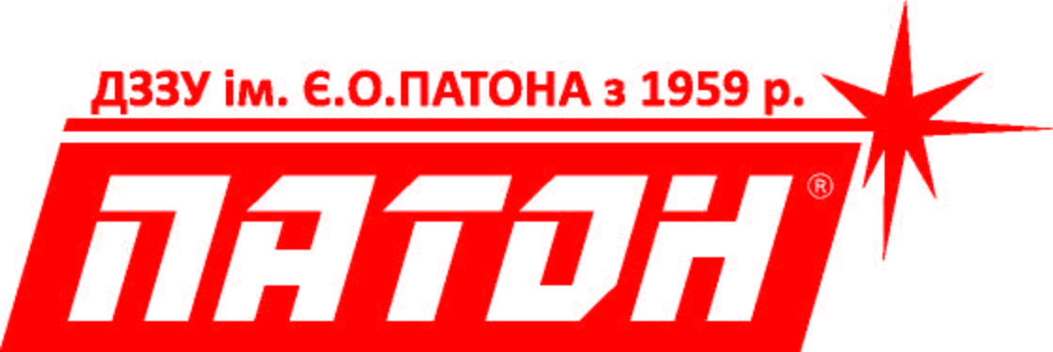Paton International

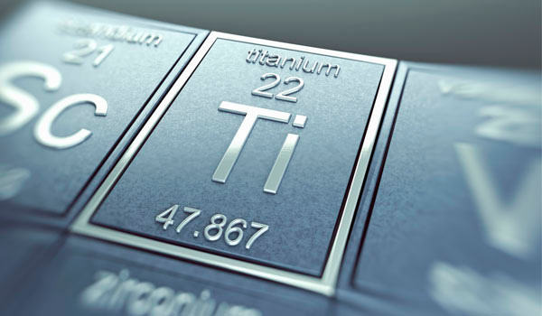SIC «Titan» of E.O. Paton Electric

Welding Institute

China-Ukraine E.O. Paton Institute

of Welding

Ultracon Service

Diagnostic Devices